

FAT Media, LLC
Attention Jamie Dodson
110 Conger Road, Madison, AL 35758-8537
256.457.3275 jamie.dodson@knology.net

Subject: Classroom Presentations
As an author I enjoy speaking with young people. I have had the opportunity to speak with many classes and am always looking for additional opportunities. I ask for no honorarium, just the chance to sell my books to the student body. I will also leave a copy of my novels for your school library.
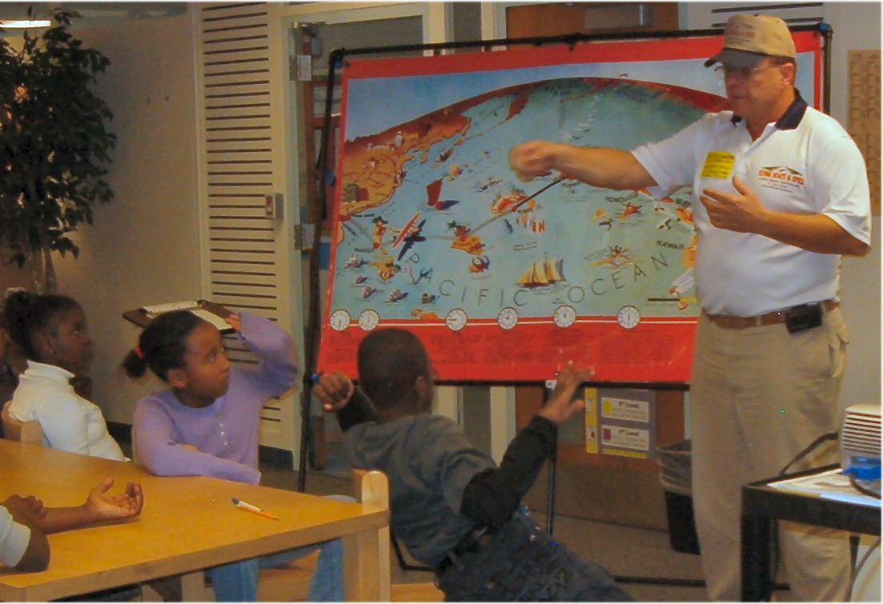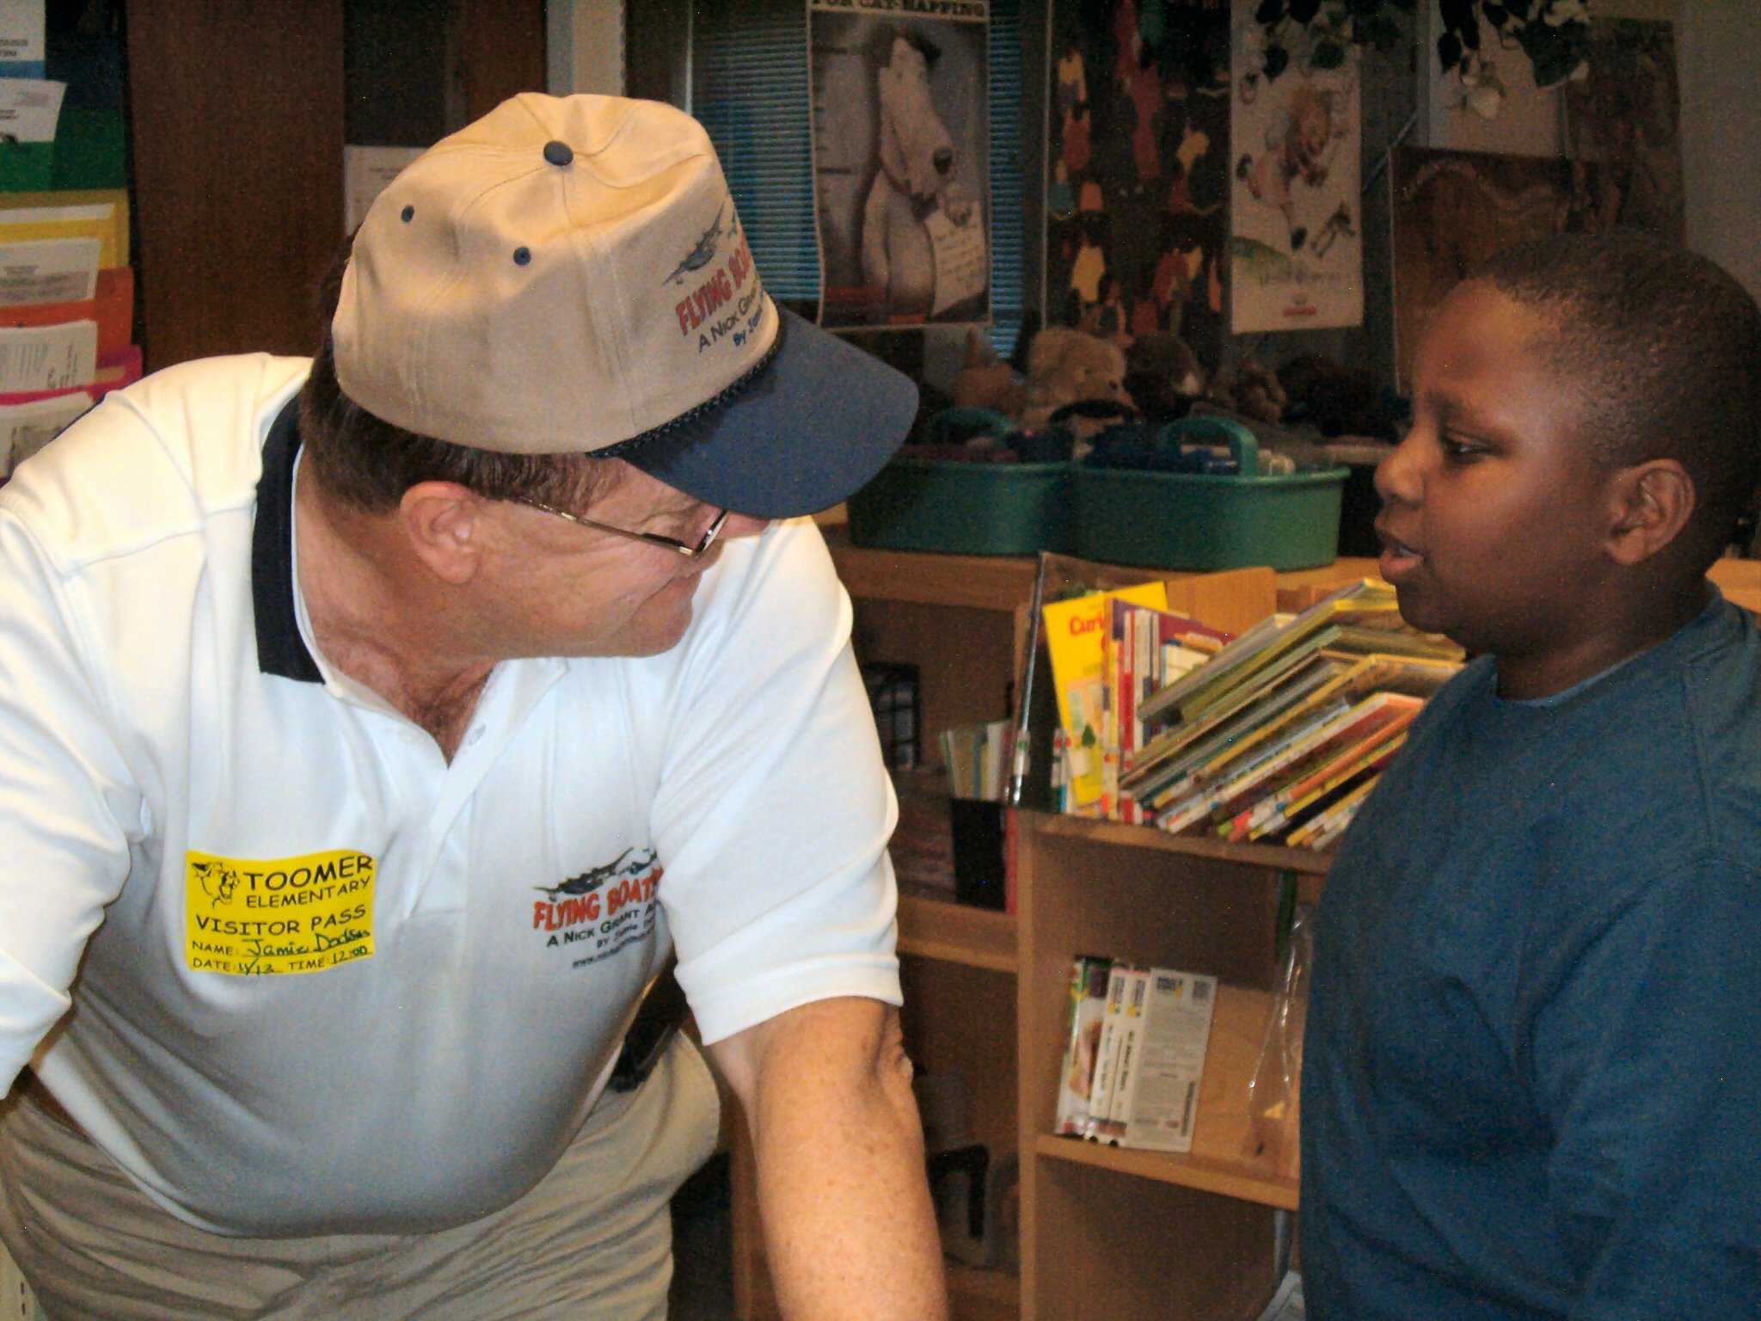
I offer a variety of presentations about the Golden Age of Aviation, airline history, air races, famous aviation personalities, and creative writing. My presentations include movie clips, large maps, posters and aviation models. They vary in length and are geared to the age group. 4th & 5th grade presentations are 20 – 30 minutes in length with a question and answer period afterwards. Middle School presentations are 40 -50 minutes. The length of the Q&A session I leave to the teacher but it’s my favorite time. I love the student interaction and enjoy their questions. While I prefer a smaller group, I also present in large auditorium settings.
I’ve listed my most popular the topics below. I look forward to speaking at your school, church, or other group meeting.
Presentations
- The Rise and Fall of Flying Boats: (Subject tie-in: History, Science and Engineering) This presentation is a great start for your classroom. The first scheduled airline used flying boats. A flying boat is an airplane whose fuselage is shaped like a boat. A flying boat can alight and land on water. Some are amphibians, planes that can also take off and land on normal runways. I will explain why flying boats were attractive to early airlines, cargo haulers, explorers and the military. I illustrate my presentation with movie clips, colorful slides and posters. I also have a number of display airliner models.
- Charles Lindbergh: (Subject tie-in: History, Science, Social Science, and Engineering) Lindbergh’s flight ignited the public’s imagination like few other events this century. To span the North Atlantic by air was incredible. To do it alone in a tiny single-engine airplane flown by a shy pilot from the Midwest, a pilot who had never even seen the ocean before, was almost unimaginable. But Lindbergh was very controversial and the US Government suspected him of collusion with enemy aliens. Was Lindbergh a racist, and a Nazi? Or was it all a cover for a secret mission for the US?
- Juan Tripp: (Subject tie-in: History, Science, Engineering and Economics)By business school standards, Juan Trippe was not a model chief executive. He didn't delegate well. He made big deals without telling his top managers. He almost single-handedly built a world airline, Pan American, but often acted as if he owned the world. He also had a vision that would change it, at least as regards airline travel. While his Pan Am does not survive today, his vision does.
- Amelia Earhart: (Subject tie-in: History, Science, Engineering, and Marketing) Next to Lindbergh the most famous name in early aviation for most people is Amelia Earhart. Earhart was the first woman to fly the Atlantic - as a passenger - on a 1928 promotional flight conceived by publisher George Putnam. Putnam had rushed out We, Charles Lindbergh's autobiography, only a month after his record flight. Seeing that the public craved more, Putnam found and recruited Earhart for one of aviation's first staged media events.
- Wiley Post: (Subject tie-in: History, Science, Engineering, and Marketing) Perhaps aviation's most impressive personal achievement in the 1930's was the one-eyed Wiley Post's second around-the-world flight. Post and navigator Harold Gatty had set the around-the-world record in 1931 at 8 days, 15 hours and 51 minutes. Two years later, Post, flying solo in his Lockheed Vega, Winnie Mae, beat his earlier record by 21 hours. Post fought Atlantic fog, Russian thunderstorms, equipment problems and his own fatigue to set the incredible record.
- Jimmy Doolittle. (Subject tie-in: History, Science, and Engineering) In 1929 "Jimmy" Doolittle made the first completely blind take-off and landing proving the practicality of instrument flight. Doolittle was unique in aviation with a doctorate degree in aeronautics from MIT, but his piloting feats eclipsed his scientific work. In 1942, he organized and led the raid on Tokyo made famous by the book and movie, “Thirty Seconds Over Tokyo”. The raid consisted of sixteen B-25 medium bombers launched from the aircraft carrier USS Hornet. Ten years earlier he won the Thompson Air Trophy flying the highly-advanced Gee Bee Racer, one of the few pilots in the thirties to have raced these planes and survived.
- Howard Hughes. (Subject tie-in: History, Science, Engineering, Mental Illness - Medicine) Howard Hughes inherited a fortune based on the rotary drill bit. He died a lonely hermit in 1976, a prisoner of mental illness, drugs and his aides. But in the thirties he and his aircraft broke every major speed and distance record. The custom-built Hughes H-1 Racer set the landplane speed record in 1935 at 352 miles per hour easily outperforming even the fastest military planes of the time. In July, 1938 he and a crew of four flying a Lockheed Lodestar broke the around-the-globe record set by Wiley Post in 1933. Two years later, Hughes was awarded the Congressional Medal of Honor for the flight.
- Air Races & The War. (Subject tie-in: History, Science, and Engineering) Air racing got its start in the United States when newspaperman Ralph Pulitzer offered a trophy to promote high-speed flight. He did this because American aircraft were making a poor showing in European air races. The first Pulitzer race was held at Mitchell Field, Long Island, New York, on November 27, 1920.
- Airlines of the United Stated Since 1914. (Subject tie-in: History, Science, and Engineering) The Worlds first airline service began operation before World War One – in Florida with flying boats. Since that time the US has almost always been the world leader in airlines. US airlines fly more people, at a lower cost and more safely that any other country. I will explain why and illustrate my presentation with movie clips, colorful slides and posters. I’ll also show how the airlines have aided every war effort since 1914.
- The role of airmail in the development of world airlines: (Subject tie-in: History, Science, and Engineering) Early airlines relied on small slow airplanes. Early flying was risky and the customer base was not well developed. Airmail was a key subsidy that enabled airlines to stay solvent while technology played catch-up. I show how aviation technology struggled to keep up with the airlines visionary leaders.
- Creative writing: 5th Grade and up (Subject tie-in: History, Science, Engineering and English) Combine aviation history with fiction writing and the action adventure genre. Jamie will discuss how to capture an idea, how to focus your efforts, structure, and market forces with exercises and examples. Jamie took his first novel from YA historical fiction, to public speaking to a movie deal in Hollywood.
Who the heck is Jamie Dodson?

Jamie’s first historical fiction novel Flying Boats and Spies, a Nick Grant Adventure, was published spring 2008. His second novel The China Clipper is scheduled for publication the fall of 2009. Hollywood Production Company Black Sheep Entertainment has purchased a movie option for Flying Boats and Spies. He conducted five years of extensive research on the era to insure accuracy. He is member of the Pan Am Historical Foundation, the OSS Foundation, Military Intelligence Corps Association. He writes non-fiction for aviation and military magazines.
Jamie is a career Intelligence officer and worked Counter Intelligence, Special Intelligence, and Signals Intelligence for US Military and Allied Intelligence Services. He has served with Joint Special Operations, Airborne Infantry, Air & Missile Defense, Army Aviation, Military Police and Allied Intelligence Agencies. He has been involved in operations in Laos, Viet Nam, Cambodia, Germany, the United Kingdom, Hungary, Croatia, Bosnia, Iraq, Saudi Arabia, Kuwait, Japan, Korea, Guam, Samoa, the Hawaiian Islands and at numerous locations across the US.
After retiring from active military service, Jamie worked as engineer for a large company before returning to the Army as a civilian Intelligence Officer and Technology Protection Engineer for Aviation and Missile Research, Development and Engineering Center (AMRDEC), Intelligence Division, Redstone Arsenal, Alabama. He holds a Systems Engineering Certificate from the University of Alabama, Huntsville, a Masters in Computers and Systems Management from Webster University and a Bachelor's in Geospatial Science from the University of Colorado.
He is married to Joan Skawski-Dodson, adjunct faculty member of the University of Alabama, in Huntsville, and formerly of Chicago. They have traveled the world and lived on three continents with their three children Ian, Neil and Glenna. They have a spoiled Australian Sheppard named Gracie and have called Huntsville, Alabama home since 2001

